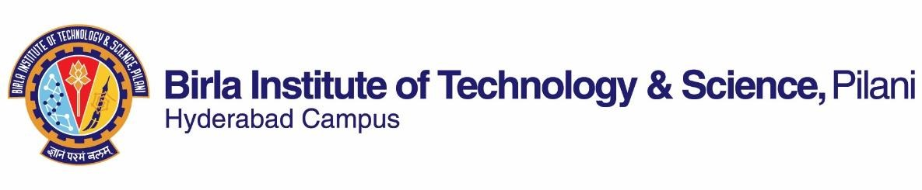

# FIRST SEMESTER 2023-2024

Course Handout Part II

Date: 11-08-2023

In addition to part-I (General Handout for all courses appended to the time table) this portion gives further specific details regarding the course.

*Course No.* : **MF F311**

*Course Title* : ***MECHATRONICS AND AUTOMATION***

*Instructor-in-Charge* : ***Dr. ARSHAD JAVED***

**Scope and Objective of the Course:** This course is intended to a comprehensive knowledge of the technology related to Mechatronics and Automation. Mechatronics is an interdisciplinary engineering domain that builds on the traditional mechanical engineering studies, combines it with technologies from the electrical, electronics, computer and control fields, using techniques such as simultaneous engineering to provide solutions in manufacturing applications. This course will develop overall background of the student in interdisciplinary mechatronic technology and a broad introduction to the issues encountered and techniques required in developing mechatronic products and automation systems.

# Textbooks:

1. W. Bolton, *Mechatronics*, 3rd Ed., Pearson, 2004. [1]

# Reference books:

1. A. Smaili and F. Mrad, *Applied Mechatronics,* Oxford University Press, 2008. [2]
2. M.P. Groover, “*Automation, Production systems, and Computer-Integrated Manufacturing*”, PHI, 2008. [3]
3. W. Stadler, *Analytical Robotics and Mechatronics*, McGraw Hill, 1995. [4]
4. Tai-Ran Hsu, [*MEMS and Microsystems: Design and Manufacture*](http://www.flipkart.com/mems-microsystems-design-manufacture-1st/p/itmdwaamcww4jgzn?pid=9780070487093&otracker=from-search&srno=t_1&query=mems&ref=b62f4b31-e1d0-491b-b7e2-1015b4200eb8)*,* John Wiley & Sons. 2008. [5]

# Course Plan:

|  |  |  |  |
| --- | --- | --- | --- |
| **Lecture No.** | **Learning objectives** | **Topics to be covered** | **Chapter in the Text**  **Book** |
| 1 | Understand mechatronics and the development of automation system through mechatronics | Introduction, Mechatronic systems – Examples | [1]-1 |
| 2 | Introduction to automation, Key issues, Approach to Mechatronics and  automation | class notes, [1]-4, [2]-14 |
| 3-7 | Understanding working principles and applications of sensors | Sensors and Instrumentation: Sensor functions, Characteristics,  Applications, Specifications & Selection | [1]-2, 3  [2]-11 |
| 8-12 |  | Actuation Systems: Pneumatic and Hydraulic actuation systems | [1]-5 |

|  |  |  |  |
| --- | --- | --- | --- |
| 13 | Understanding the working principles and applications of different actuation and transmission systems used for automation | Mechanical actuation and systems | [1]-6, class notes |
| 14-19 | Electrical Actuators | [1]-7, [2]-12,  class notes |
| 20-21 | Torque estimation, Performance & Selection of actuation system | [2]-12, class notes |
| 22-24 | Understanding basic control concepts | Open-loop, close-loop, proportional derivative, integral, multivariable, digital,  adaptive control systems | [1]-13, class notes |
| 25-26 | Understanding the application and implementation of automatic control for small and large automation systems | Digital electronics, Digital logic, Microprocessors | [1]-14, 15 |
| 27-29 | Programmable and selection of PLC’s (Programmable Logic Controller) | [1]-19, 21  class notes |
| 30-32 | Student will know the architecture and classification of Industrial Automation | Introduction of Industrial Automation | Class notes |
| 33-35 | Student will able to understand the basics,  components, structure and classification of SCADA system | Introduction to SCADA system | Class notes |
| 36-38 | Understanding the application of Industrial manipulator | Introduction, specification, selection and programming of industrial manipulator  (robot). | class notes |
| 39-40 | Understanding the challenges in **real time**  Mechatronics and Automation system | Case-Studies | [2]-14, [4],  class notes |

**Evaluation Scheme:**

|  |  |  |  |  |
| --- | --- | --- | --- | --- |
| **Component** | **Duration** | **Weightage (%)** | **Date & Time** | **Nature of Component** |
| Mid semester Test | 90 min | 20 | 13/10 - 4.00 - 5.30PM | Close Book |
| Quiz | -- | 15 |  | Open Book (10%) |
| Laboratory | -- | 25 |  | --- |
| Comprehensive- Examination | 180 min | 40 | 19/12 AN | Close & Open (at least 20%) Book |

**Chamber Consultation Hour:** Will be decided based on Time table and availability of the students.

**Notices:** The necessary announcements will be made in the classroom itself.

**Make-up Policy:** Make-up will be given with prior concern and genuine reasons only.

**Academic Honesty and Integrity Policy:** Academic honesty and integrity are to be maintained by all the students throughout the semester and no type of academic dishonesty is acceptable.

**Plagiarism and AI tool policy:** All take home assignment should be free from any plagiarism and application of (AI) Artificial Intelligence tools. If found, the marks of that component will be nullified.

# INSTRUCTOR-IN-CHARGE